MAULANA ABUL KALAM AZAD UNIVERSITY OF TECHNOLOGY

*Numerical Analysis in C*

*(Computer assignment)*



Rohit Das

B. Tech (CSE, 2ND year)

Roll NO.: **30000114022**

REGN. NO.:**143000110023**

TEACHER: ATREYEE SARKAR

INDEX

|  |  |  |  |
| --- | --- | --- | --- |
| Serial | Date | Assignment | Signature |
|  |  |  |  |
|  |  |  |  |
|  |  |  |  |
|  |  |  |  |
|  |  |  |  |
|  |  |  |  |
|  |  |  |  |
|  |  |  |  |
|  |  |  |  |
|  |  |  |  |
|  |  |  |  |
|  |  |  |  |
|  |  |  |  |
|  |  |  |  |
|  |  |  |  |

**Assignment 1:**

**Write a C program to implement Newton-Rhapson Method and find the root of the following function within a given range, up to user-specified decimal places.**

x

#include<stdio.h>

#include<math.h>

float x,x1,a,b,ep,p;

int choice,i=0;

float fun(float);

float funcx(float);

float dfunc(float);

float ab(float);

void main()

{

printf("Enter range for root:\n");

scanf("%f%f",&a,&b);

printf("Enter absolute error value:\n");

scanf("%f",&ep);

printf("Enter choice to assign x's value(0/1):\n");

scanf("%d",&choice);

printf("n \t x(n) \t\t x(n+1) \t fx(x(n+1) \n)");

x=(choice==0)?a:b;

x1=funcx(x);

printf("%d \t %4f \t %4f \t %4f \n",i,x,x1,fun(x1));

while(ab(fun(x1))>ep){

i++;

x=x1;

x1=funcx(x);

printf("%d \t %4f \t %4f \t %4f \n",i,x,x1,fun(x1));

}

printf("The root of the function is: %f \n",x);

}

float fun(float p)

{

return (p*exp(p)-cos(p));

}

float dfunc(float p)

{

return ((p+1)*exp(p)+sin(p));

}

float funcx(float p)

{

return p-(fun(p)/dfunc(p));

}

float ab(float p)

{

p=p>0?p:(p*(-1));

}

Output: 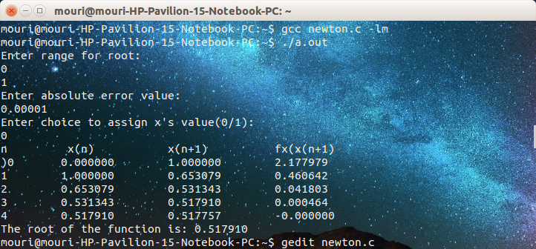

**Assignment 2:**

**Write a C program to implement Regular Falsi Method and find the root of the following function within a given range, up to user-specified decimal places.**

x

#include<stdio.h>

#include<math.h>

float w,a,b,ep,p,q,diff=0;

int i=0;

float fun(float);

float funcx(float,float);

float ab(float);

void main()

{

printf("Enter range for root:\n");

scanf("%f%f",&a,&b);

printf("Enter absolute error value:\n");

scanf("%f",&ep);

w=funcx(a,b);

printf("n \t a \t\t b \t\t w \t\t fx(w)\n)");

printf("%d \t %4f \t %4f \t %4f \t %4f \n",i,a,b,w,fun(w));

do{

if(fun(w)<0){

diff=w-a;

a=w;

}

else{

diff=w-b;

b=w;

}

i++;

w=funcx(a,b);

printf("%d \t %4f \t %4f \t %4f \t %4f \n",i,a,b,w,fun(w));

}while(ab(diff)>ep);

printf("The root of the function is: %f \n",w);

}

float fun(float p)

{

return (cos(p)-(p*exp(p)));

}

float funcx(float p,float q)

{

return (p*fun(q)-(q*fun(p)))/(fun(q)-fun(p));

}

float ab(float p)

{

p=p>0?p:(p*(-1));

}

Output:

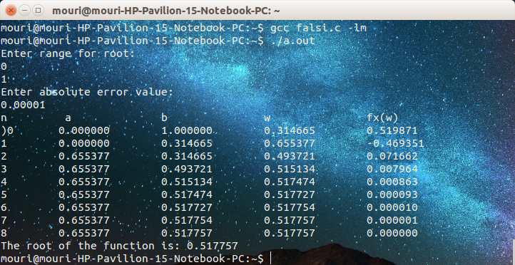

**Assignment 3:**

**Write a C program to implement Trapezoidal rule to find out the value of integration of the given function up to 4 decimal places.**

=

#include<stdio.h>

float func(float);

void main()

{

float a,b,x,h,p,sum=0;

int n,i;

printf("Enter lower range:\n");

scanf("%f",&a);

printf("Enter upper range:\n");

scanf("%f",&b);

printf("Enter no. of sub-intervals:\n");

scanf("%d",&n);

h=(b-a)/n;

printf("x \t \t| y=f(x)\n");

printf("%f \t | %f\n",a,func(a));

for(i=1;i<n;i++){

p=a+(i*h);

sum+=2*(func(p));

printf("%f \t | %f\n",p,func(p));

}

printf("%f \t | %f\n",b,func(b));

sum=(h/2.0)*(sum+func(a)+func(b));

printf("Using trapezoidal theorem, the value of integration is: %f\n",sum);

}

float func(float x)

{

return (x/(1+x));

}

Output:

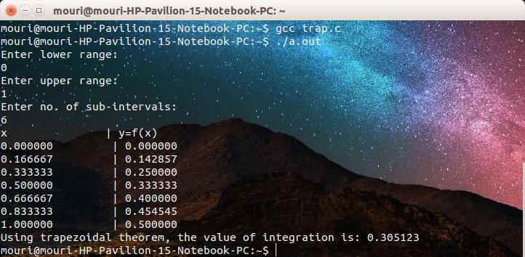

**Assignment 4:**

**Write a C program to implement Simpson’s 1/3rd rule to find out the value of integration of the given function up to 4 decimal places.**

=

#include<stdio.h>

float func(float);

void main()

{

float a,b,x,h,p,sum1=0;

float sum2=0;

float sum=0;

int n,i;

printf("Enter lower range:\n");

scanf("%f",&a);

printf("Enter upper range:\n");

scanf("%f",&b);

printf("Enter no. of sub-intervals:\n");

scanf("%d",&n);

h=(b-a)/n;

printf("x \t \t| y=f(x)\n");

printf("%f \t | %f\n",a,func(a));

for(i=1;i<n;i++){

p=a+(i*h);

if(i%2==0){

sum1+=func(p);

}

else sum2+=func(p);

printf("%f \t | %f\n",p,func(p));

}

printf("%f \t | %f\n",b,func(b));

sum=(h/3.0)*((2*sum1)+(4*sum2)+func(a)+func(b));

printf("Using Simpson's !/3rd rule, the value of integration is: %5.4f\n",sum);

}

float func(float x)

{

return (x/(1+x));

}

Output:

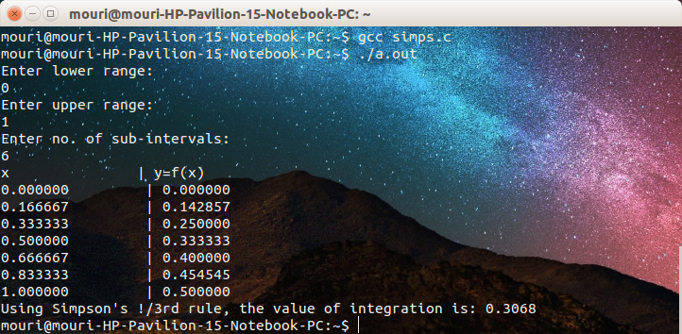

**Assignment 5:**

**Write a C program to implement Euler’s method to find out the value of the given expression up to 4 decimal places.**

#include <stdio.h>

float x1,x2,x,y,yd,h;

int n;

float func(float,float);

void main()

{

printf("Enter the initial values of x0,y0 and h:\n");

scanf("%f%f%f",&x,&y,&h);

printf("Enter the range for x:\n");

scanf("%f%f",&x1,&x2);

printf("n \t x \t \t y \t \t y' \n");

n=0;

printf("%d \t %f \t %f \t %f \n",n,x,y,yd);

while(x<(x2-h)){

yd=func(x,y);

x+=h;

y=y+(h*yd);

n++;

printf("%d \t %f \t %f \t %f \n",n,x,y,yd);

}

printf("The value of the expression is: %f\n",y);

}

float func(float a,float b)

{

return ((b-a)/(b+a));

}

Output:

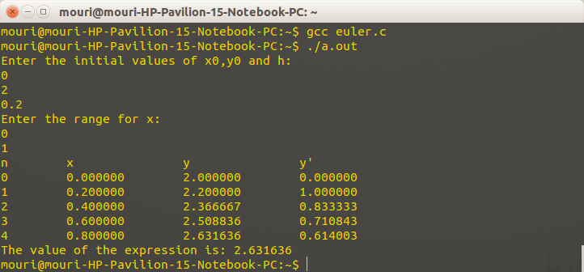

**Assignment 5:**

**Write a C program to implement Euler’s method to find out the value of the given expression up to 4 decimal places.**

#include<stdio.h>

float x1,x2,x,y,k1,k2,k3,k4,h;

int n=0;

float func(float,float);

void main()

{

printf("Enter the values of x0,y0,h:\n");

scanf("%f%f%f",&x,&y,&h);

printf("Enter the range of x:\n");

scanf("%f%f",&x1,&x2);

printf("n \t x \t y\n");

printf("%d \t %.2f \t %.5f\n",n,x,y);

while(x<(x2-h)){

k1=func(x,y);

k2=func((x+(h/2.0)),(y+(k1*(h/2.0))));

k3=func((x+(h/2.0)),(y+(k2*(h/2.0))));

k4=func((x+h),(y+(k3*h)));

x+=h;

y=y+((h/6.0)*(k1+(2*k2)+(2*k3)+k4));

n++;

printf("%d \t %.2f \t %.5f\n",n,x,y);

}

printf("The value of the expression is: %.5f\n",y);

}

float func(float a,float b)

{

return (a*b);

}

Output:  
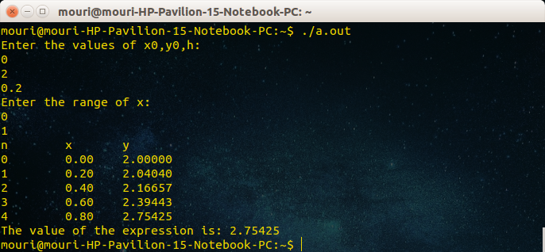

**Assignment 5:**

**Write a C program to implement Gauss Seidel’s method to find out the value of the variables in the given equations up to 4 decimal places.**

#include<stdio.h>

#include<math.h>

int i,j,k, con[3], coeff[3][3];

float ep, x[3][1000];

void main()

{

printf("Enter values of matrix for linear equations:\n");\

for(i=0;i<3;i++){

for(j=0;j<3;j++)scanf("%d",&coeff[i][j]);

}

printf("Enter value of constants:\n");

for(i=0;i<3;i++)scanf("%d",&con[i]);

printf("Enter value of epsilon:\n");

scanf("%f",&ep);

x[0][0]=x[1][0]=x[2][0]=0;

printf("Coefficient matrix:\n");

for(i=0;i<3;i++){

for(j=0;j<3;j++)printf("%d ",coeff[i][j]);

printf("\n");

}

printf("Constant matrix:\n");

for(i=0;i<3;i++)printf("%d \n",con[i]);

i=0;j=0;k=0;

printf(" x y z\n===============================\n");

while(1){

x[0][i+1]=(con[0]-coeff[0][1]*x[1][i]-coeff[0][2]*x[2][i++])/coeff[0][0];

x[1][j+1]=(con[1]-coeff[1][0]*x[0][i]-coeff[1][2]*x[2][j++])/coeff[1][1];

x[2][k++]=(con[2]-coeff[2][0]*x[0][i]-coeff[2][1]*x[1][j])/coeff[2][2];

printf("%.4f %.4f %.4f\n",x[0][i],x[1][j],x[2][k]);

if(fabs(x[2][k]-x[2][k-1])<ep)break;

}

printf("x= %.4f, y= %.4f, z= %.4f \n",x[0][i],x[1][j],x[2][k]);

}

Output:

